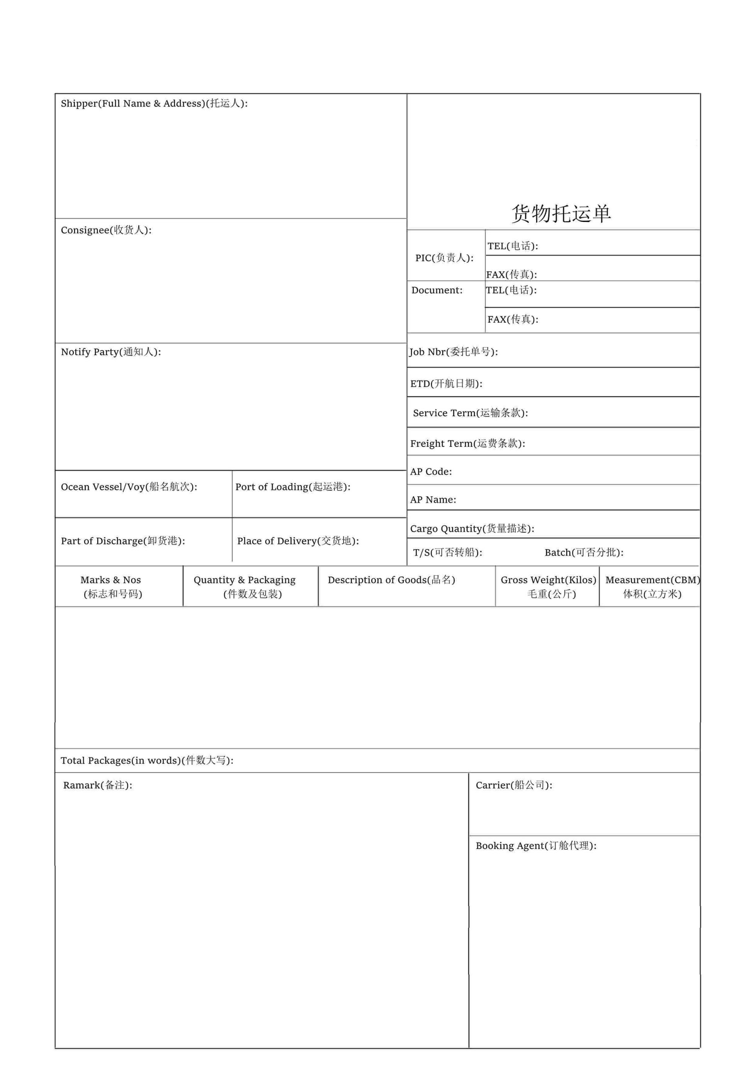

**上海如润风国际物流有限公司**

JYDSEM21090359

胡金龙

上海如润风国际物流有限公司

1058

SHANGHAI JIYIDA INTERNATIONAL LOGISTICS CO.,LTD\N RM1304-1306,BULIDING A,HESHENG FORTUNE PLAZA,\N NO.839 DALIAN RD, HONGKOU DIS,SHANGHAI,CHINA\N TEL:021-63930701\N FAX:021-63930650

HEUMEN LOGISTICS BV

PIETER ZEEMANWEG 167 3316, GZ DORDRECHT

TEL:0031 10 4296097

SAME AS CONSIGNEE

SHANGHAI

ROTTERDAM

ROTTERDAM

CARTONS

To:

11/21 EVER GOLDEN 1219-020W   1*40HQ

O/F:USD1900+ENS

加拼20个关单号

FM:如润枫

TOTAL:ONE THOUSAND ONE THOUSAND FIFTY EIGHT(1058)CARTONS ONLY.

PP

40HQX1

40HQX1

021-63930701

14231.75KGS

66.23CBM

CY-CY

256

EVER ACT V.1157-001W